M01 - Testing Foundations & QA Mindset

Bug Report 1
Summary: Can create an account using emojies of first and last name input fields
Envirement: Register Page
Steps:
- Go to Register Page
- Complete first and last name fields with emojies and the rest of fields with correct data
- Press button “Ma inregistrez”
- I was redirected to “Sign In” page
- In account confirmation email, I pressed button “Confirma Email-ul” and I was redirected to “My Account” page.
Expected:
User receive an error message for invalid character
Actual:
Account created successfully with an invalid name
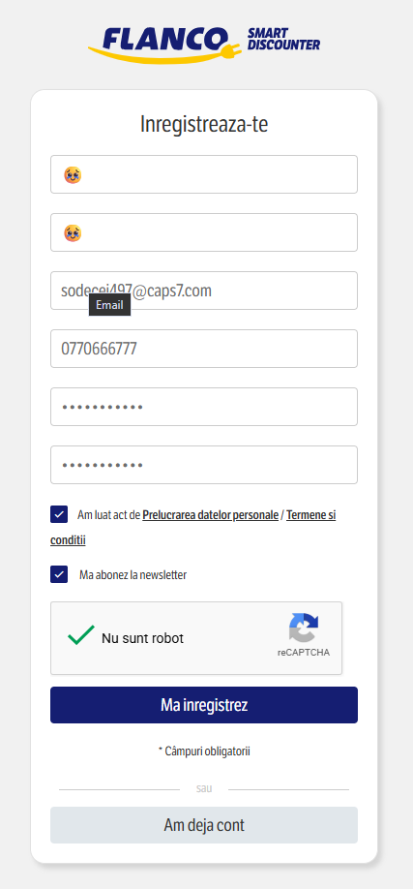
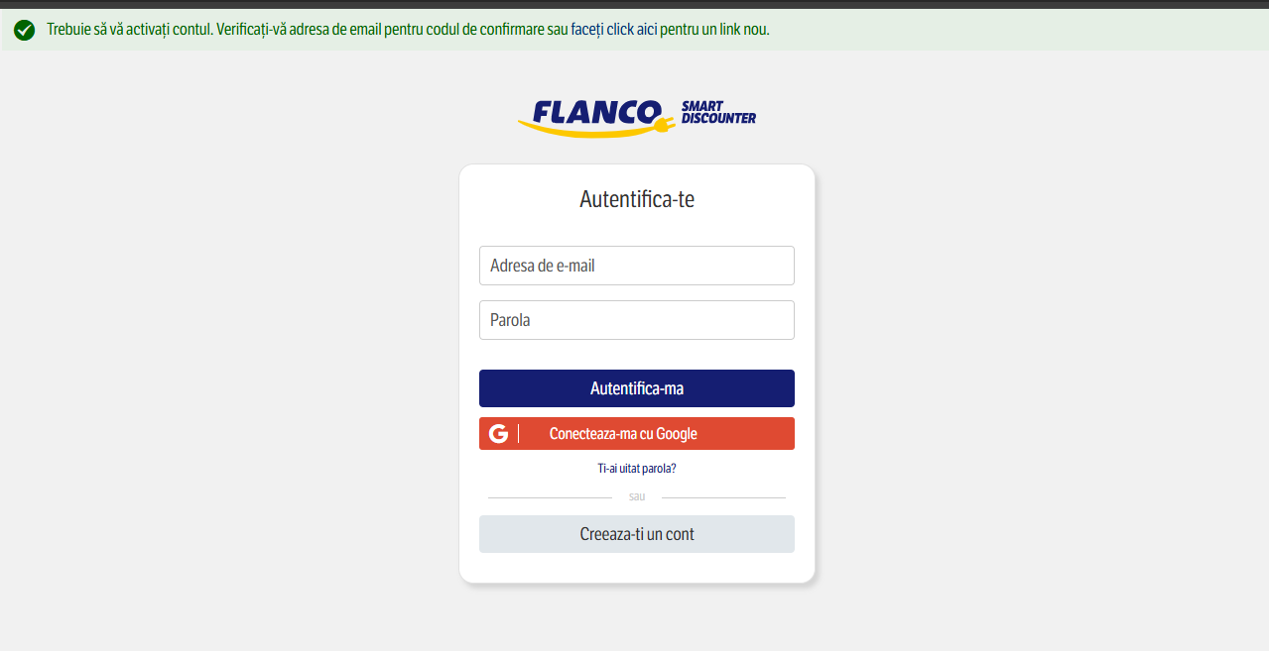
Evidence:
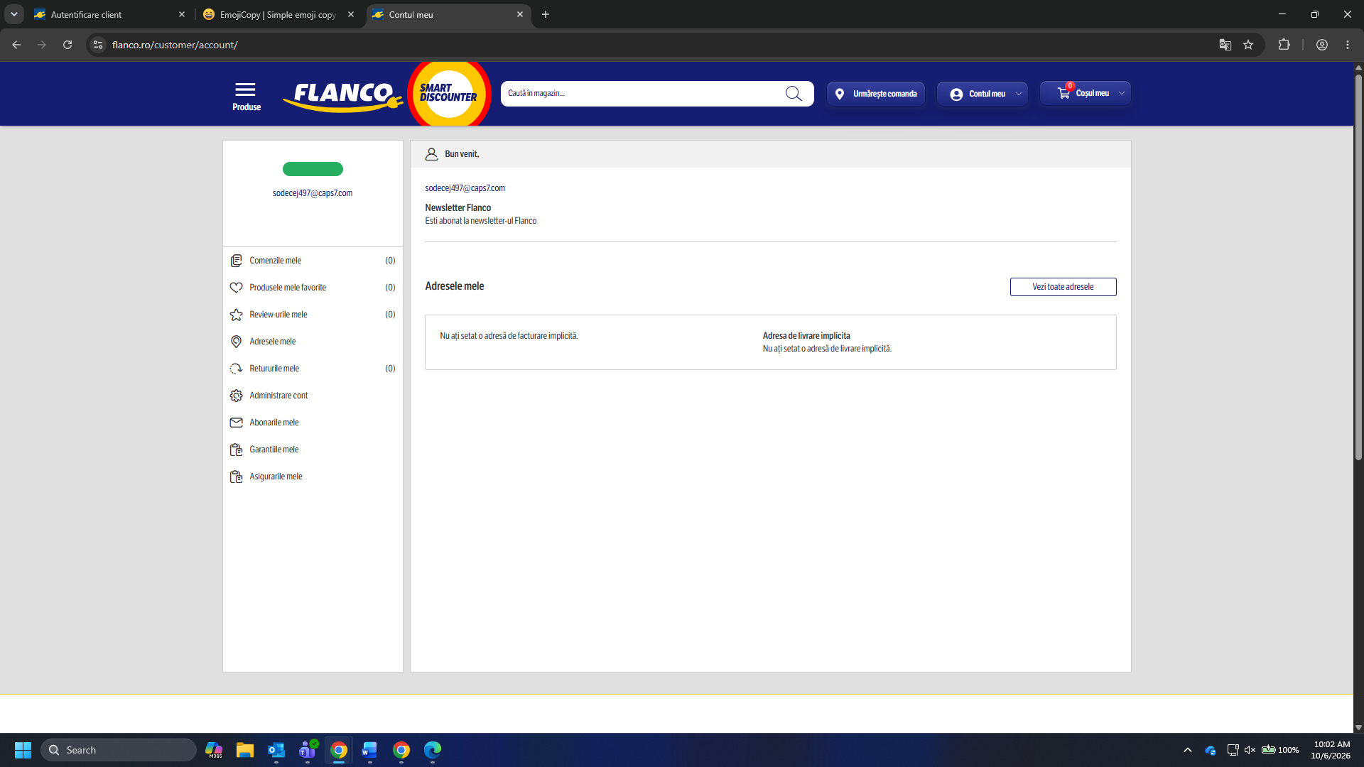

Bug Report 2
Summary: Sign In with an account which has corrupted first and last name
Envirement: Sign In Page
Steps:
- Go to Sign In
- Complete form fields with email and password
- Press button “Autentificare”
- I was redirected to Home Page
- First time, specific logged in user navigation buttons don’t appear, but after a refresh, appear the log in form and user navigation buttons
Expected:
User with corrupted data it shouldn’t be possible to authenticate
Actual:
User authenticated successfully and sign in form and user navigation buttons appear
Evidence:
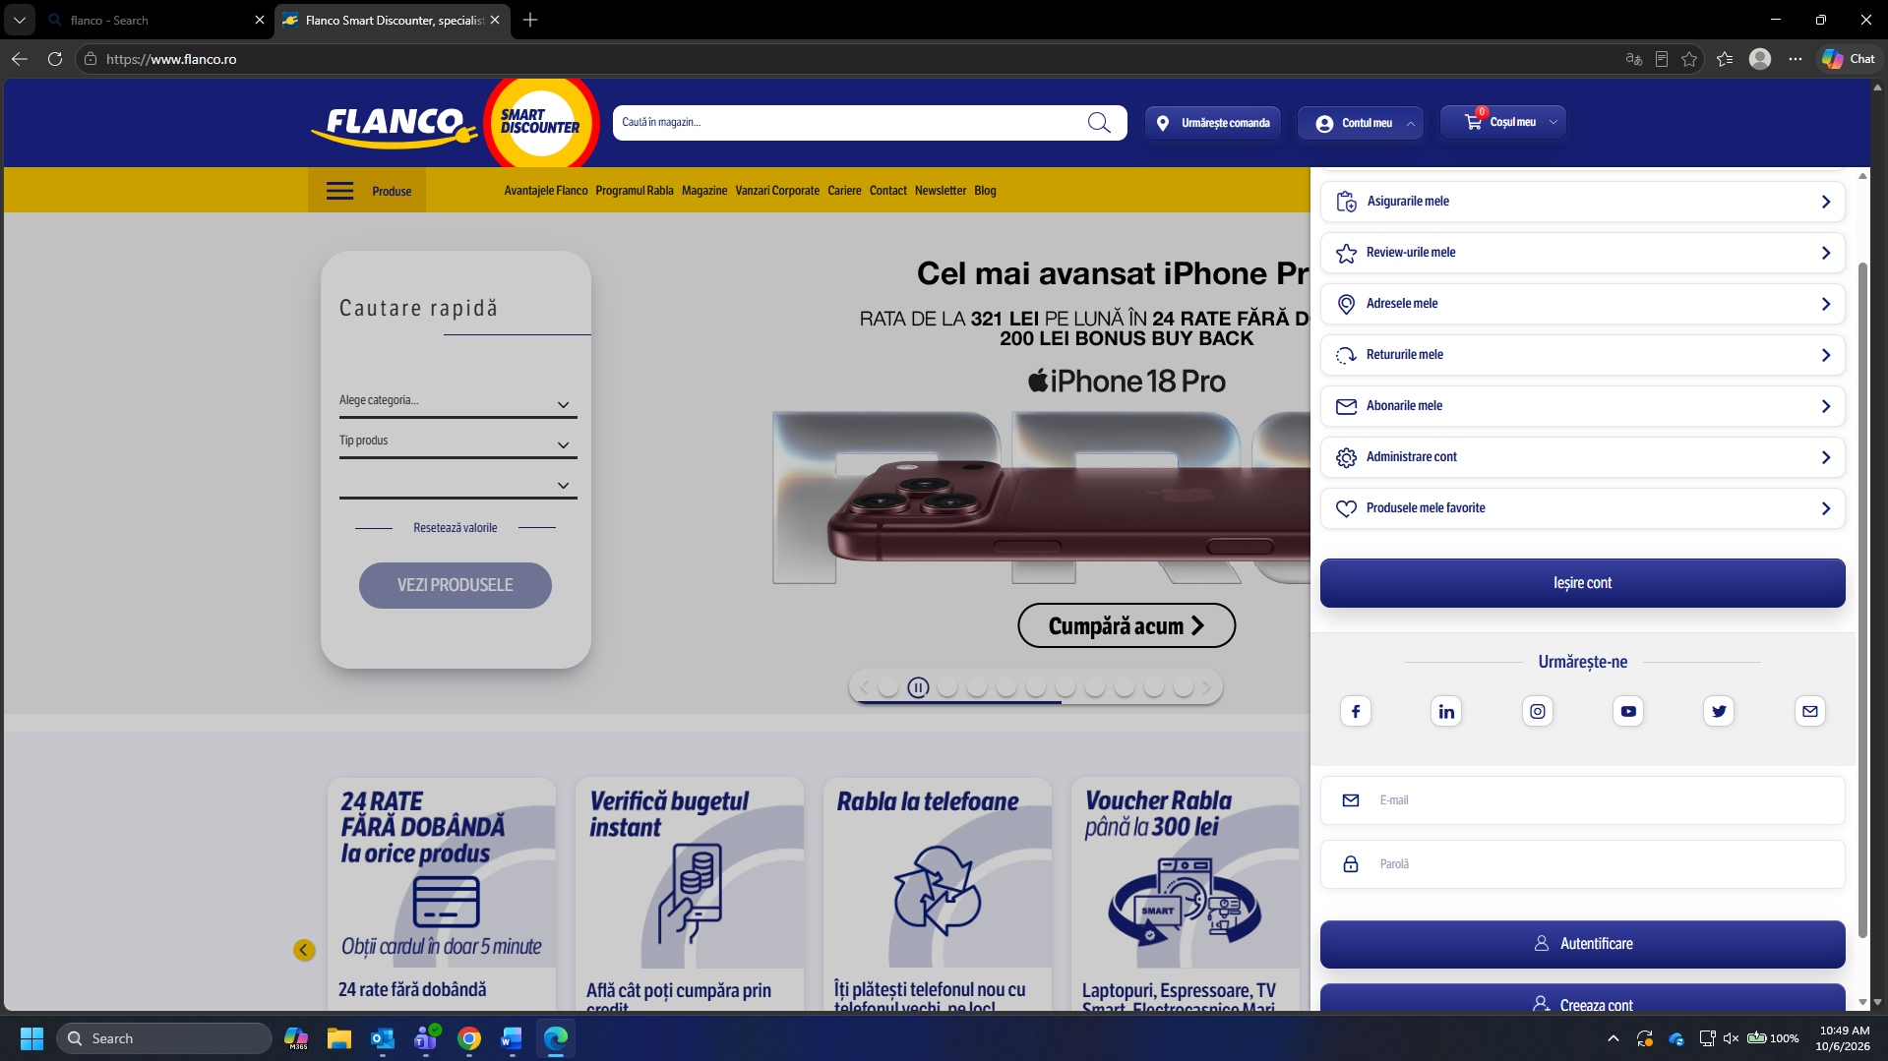
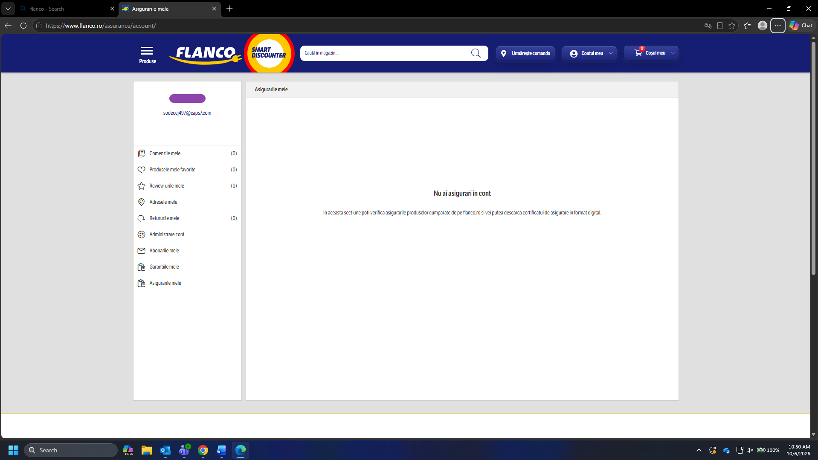

Bug Report 3
Summary: User don’t receive any error messages if complete any fields from address form with emojies
Envirement: Customer Addresses page and User must be logged In
Steps:
- Sign In with a corrupted user
- Go to Customer Addresses page
- Complete the first or last name field with an emoji
- Press button “Salveaza Adresa”
- User is redirected to the same page with an empty form and no errors. Address isn’t saved
- Errors appear in DevTool (F12)
Expected:
Receive an error message and address don’t save.
Actual:
Don’t receive an error message bu address don’t save.
Evidence:
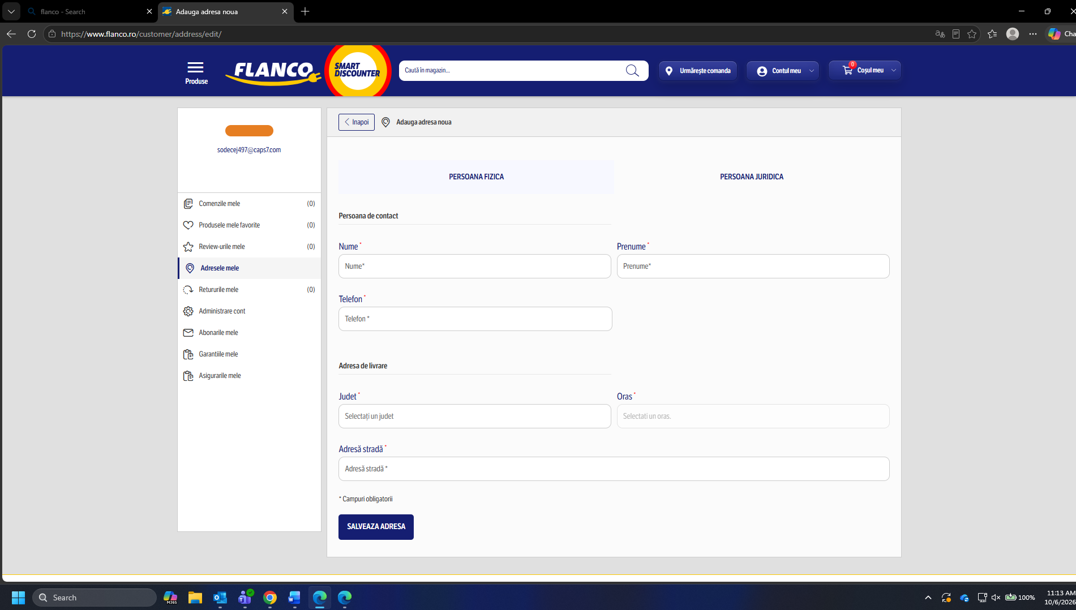
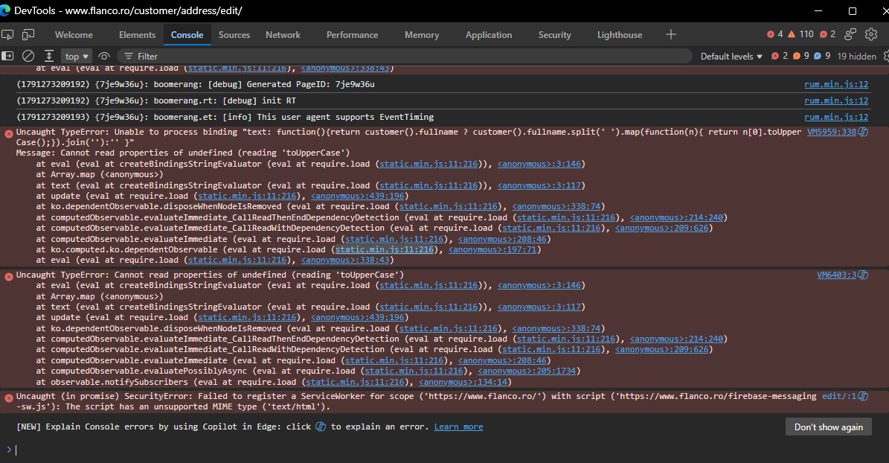

Test Case
Title/ID: TC001 – Verify if user can create an account with first and last name emojies
Preconditions:
- User must be logged out
- New account with corrupted data
  - Nume: 😄
  - Prenume: 😄
  - Adresa de email: sodecej497@caps7.com
  - Numar de telefon: 0770777666
  - Parola: ParolaTare!
- User must be on register page
Steps
- Complete all fields with corrupted dummy data
- Check all boxes
- Press button “Ma inregistrez”
- Wait for confirmation email
- In account confirmation email, press button “Confirma Email-ul” and I was redirected to “My Account” page.
Expected Results:
User must receive an error message and account registration process must be stopped

Test Case
Title/ID: TC002 – Verify if user can sign In with a corrupted account
Preconditions:
- User must be logged out
- User must to be on login page
- New account with corrupted data
  - Adresa de email: sodecej497@caps7.com
  - Parola: ParolaTare!
Steps
- Complete all fields with dummy data
- Press button “Autentificate”
- After user is redirected to home page, verify if user navigation buttons is shown
- Refresh page and verify if user navigation buttons is shown
Expected Results:
User can’t authenticate or if pass the authentication process, user shouldn’t be logged in, because is an invalid user.

Test Case
Title/ID: TC003 – Verify if I can add an address with first or last name emojies
Preconditions:
- User must be logged in
- User must be on Customer Addresses page
- New address with corrupted data
  - Nume: 😄
  - Prenume: 😄
  - Numar de telefon: 0770777666
Steps
- Complete all fields with corrupted dummy data
- Press “Salveaza Adresa”
- Press button “Ma inregistrez”
Expected Results:
User must receive an error message and address isn’t save

Describe minimum 2 testing tehniques.
- BlackBox Testing
This technique focuses on the functionality of the software without knowledge of its internal structure. Testers verify the system's behavior against the requirements.
- Error Guessing
Based on the tester’s past experience, it involves guessing potential error-prone areas and designing test cases accordingly.

